AI IN AGRICULTURE USING UAV TO DETECT WEEDS
Karanpreet Verma¹
¹Amity University, Noida, UP, and India
Email Id: karanpvrma@gmail.com

To keep track of agronomic and environmental variables, UAV’s have displayed a tremendous capabilities by capturing pictures at High spatial resolution. Ground-control-points (GCPs) must have to obtained to make sure the precision of the mosaicing process. This study was put through into wheat field naturally overspread by grass leaves and big-leaved at large initial phenological level. UAV flying at altitudes of 30 to 100 m and using a large number of GCPs (15 to 60) , ultra-high spatial resolution ortho-images is able to give rise to ultra- high spatial resolution ortho-images can be generated with the geo-referencing precision necessary to map small weeds in the field of wheat at very initial phenological stage. 1 acre field was divided into 4 sub-fields equally, 15 GCP's of different colour configurations were placed in each 4 sub fields providing a precise percentage of weeds in each sub fields detected using UAV. The outcome of the weed detection would give out the exact usage of the pesticide as per the weed detected (%) in each 4-sub field rather than, spraying the pesticide on the whole entire field.

Keywords: Image Processing, Sensor, UAV, GCPs, Flight Range.

References:
- McKinion, J. M., and H. E. Lemmon. "Expert systems for agriculture." Computers and Electronics in Agriculture 1.1 (1985):31-40.

- Gay, Alan P., et al. "Developing unmanned aerial vehicles for local and flexible environmental and agricultural monitoring." Proceedings of RSPSoc 2009 Annual Conference. Vol. 8. No. 11.2009.

- Raafat, Amany I., Mona Eid, and Magda B. El- Arnaouty. "Radiation synthesis of superabsorbent CMC based hydrogels for agriculture applications." Nuclear Instruments and Methods in Physics Research Section B: Beam Interactions with Materials and Atoms 283 (2012):71-76.

- Stockwell,V.O.,andB.Duffy."Useofantibiotics in plant agriculture." Revue Scientifique Et Technique-Office International Des Epizooties 31.1 (2012).

- Peña,JoséManuel,etal."Weedmappinginearly- season maize fields using object-based analysisof unmanned aerial vehicle (UAV) images." PloS one 8.10(2013).

Figure:
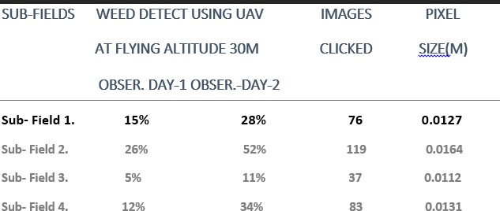
Table1, showcases the weeds that were detected in the various 4 subfields in(%) using UAV ,flying at the
altitude 30 m on observation day 1 and then gaped 15 days with an observation day 2.

